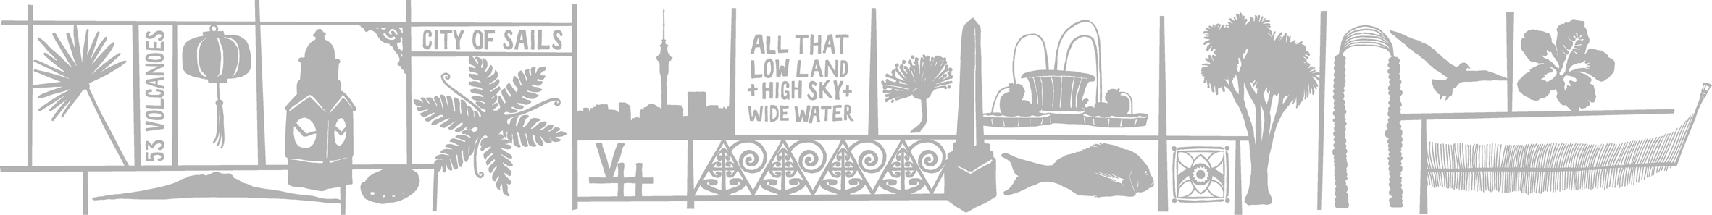

 MEDIA RELEASE

11 April 2007

Shadow of Math

Simple tasks like putting out the rubbish and making a cup of tea are translated into art works in Jonathan Brown’s exhibition Shadow of Math at Artstation from 26 April to 8 May.

Informed by elements of game theory, a mathematical method of decision-making, Brown uses a camera to record and measure the duration of everyday activities such as putting out the rubbish. He then manipulates and blends these images using digital media, computer animation programmes and painting.

This amalgamation of new and traditional art-making processes results in an exciting series of large, expressive multi-layered paintings, suggesting a fascinating relationship between new technologies and the individual expression of the artist. Titles such as “7.30am breakfast multi-task” and “One scoop colour wash, high level cold, heavy duty 30m cycle” also remind us of the work’s humble origins.

Jonathan Brown is an Auckland-based artist and has a Master of Art and Design from Auckland University of Technology. His work has been shown widely throughout Auckland and has also been included in several national and international exhibitions.

Jonathan’s work recently featured in the New Zealand Painting and Printmaking Award 2007 in Waikato, and Satellite at Shanghai Biennale 2006, China. Jonathan also works as a technician and exhibition installer at St Paul’s Street Gallery.

For more information about upcoming exhibitions, please contact Artstation on 09 376 3221 or visit www.aucklandcity.govt.nz/artstation

Ends

Notes to editors

Shadow of Math exhibition information:
Artists: Jonathan Brown

Exhibition: 26 April to 8 May

Opening: 5pm to 7pm, Tuesday 24 April

Artstation, Auckland City’s community visual arts facility, is located at the old police barracks at 1 Ponsonby Road, Newton. It is easy to get to by public transport with the Link’s ‘Artstation’ bus stop right outside.

Artstation information
Phone: (09) 376 3221
Email: artstation@aucklandcity.govt.nz
Web address: www.aucklandcity.govt.nz/artstation
Artstation gallery hours: Monday to Friday 9am to 5pm
Saturday 10am to 4pm

For further information, please contact:
Eve Armstrong, gallery coordinator
ph (09) 376 3221
email: eve.armstrong@aucklandcity.govt.nz

For media assistance, please contact:
Joelle Talbot, communications and marketing
ph (09) 357 1744 or 0274 842 622

Ref: EA

